# Finding the Domain of a Logarithmic Function

When finding the domain of a logarithmic function, it is important to remember that the domain consists only of positive real numbers. That is, the argument of the logarithmic function must be greater than zero.

Given a logarithmic function, we can find the domain by

Set up an inequality showing the argument greater than zero.

Solve for $x$.

Write the domain in interval notation.

Examples: Find the domain of each of the following.

$f\left(x\right)=\log_{5}\left(x-2\right)+1$

$f\left(x\right)=\log{(5-2x)}$

# Characteristics of the Graph of the Parent Function $f\left(x\right)=\log_{b}\left(x\right)$

Recall that exponential functions and logarithmic functions are inverses of each other. As you can see below, this means that the $x$- and $y$-coordinates are reversed for the inverse functions.

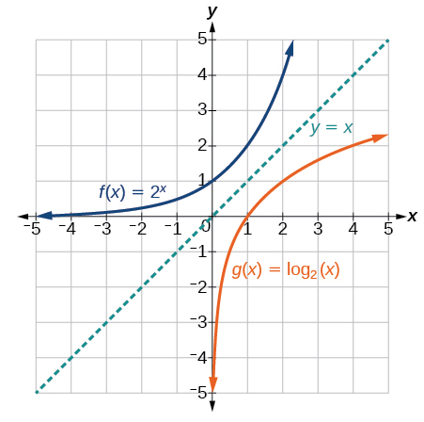

Notice that the graph of $f\left(x\right)=2^{x}$ and $g\left(x\right)=\log_{2}\left(x\right)$ are reflections about the line $y=x$.

A logarithmic function with the form $f\left(x\right)=\log_{b}\left(x\right)$, $b>0$, $b≠1$,

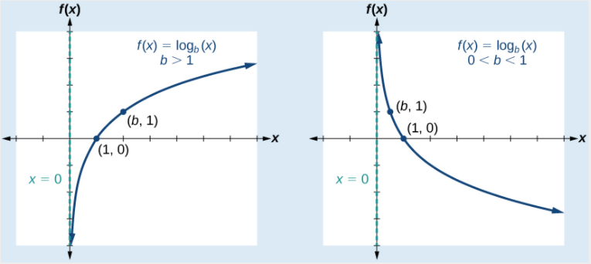

has the following characteristics:

One-to-one function

Vertical asymptote: $x=0$

Domain: $(0, ∞)$

Range: $(-∞, ∞)$

$x$-intercept: $(1,0)$

$y$-intercept: none

Increasing if $b>1$

Decreasing if $0<b<1$

Examples: For each of the following, sketch a graph of the function and then state the domain, range, and asymptote.

$f\left(x\right)=\log_{5}\left(x\right)$

$f\left(x\right)=\log_{\frac{1}{5}}\left(x\right)$

Transformations of logarithmic graphs behave similarly to those of other functions. Just as with other parent functions, we can apply the four types of transformations—shifts, reflections, stretches, and compressions—to the parent function $f\left(x\right)=\log_{b}\left(x\right)$ without loss of shape.

# Graphing Transformations of Logarithmic Functions

A translation of a logarithmic function has the form

$$f\left(x\right)=a\log_{b}\left(x±c\right)±d$$

Where the parent function, $y=\log_{b}\left(x\right)$, $b>1$, is

Reflected across the $x$-axis when $a<0$

Stretched vertically by a factor of $\left|a\right|$ if $\left|a\right|>1$

Compressed vertically by a factor of $\left|a\right|$ if $0<\left|a\right|<1$

Shifted horizontally $c$ units

Shifted vertically $d$ units

For $f\left(x\right)=\log\left(-x\right)$, the graph of the parent function is reflected about the $y$-axis.

Examples

1. Graph $f\left(x\right)=\log_{4}{(x+2)}+3$. Find the domain, range, and asymptote.

1. Write an equation for the function described below. Give the vertical asymptote, the domain, and the range.

$f\left(x\right)=\log_{2}\left(x\right)$ is stretched vertically by a factor of $4$, reflected across the $x$-axis and shifted right 3 units.

1. What is the vertical asymptote of $f\left(x\right)=-2\log_{3}\left(x+4\right)+5$?
2. Suppose the parent function is $f\left(x\right)=\log_{3}\left(x\right)$. Give an equation of the function graphed below.

